**Institute of Technology Tralee**

**Computing Department**

**Object Oriented Programming 1**

**__________________________________________________**

**Session 2 – Decision-making**

**(a)** Write a Java program that will display the message “You are less than 20 years old” if the user enters an age value under 20 and “You are at least 20 years old” if the user enters an age value of 20 or more. The program will now run as follows:

**Run 1 – The user enters a value below 20**

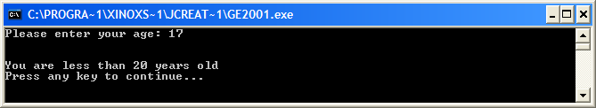

**Run 2 – The user enters a value of 20 or greater**

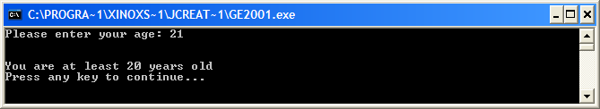

**(b)** Write the main() of a Java program that asks the user to enter their name and address. If the name matches the string “Joe Bloggs” and the address matches the string “Tralee” then the user should be given the message “You are Joe Bloggs from Tralee” (use the variables here to display the values). Otherwise they should be given the message “You definitely are not Joe Bloggs from Tralee”. Your program should run as follows:

**Run 1 – The user enters “Joe Bloggs” and “Tralee”**

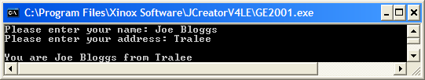

**Run 2 – The user does not enter “Joe Bloggs” and “Tralee”**

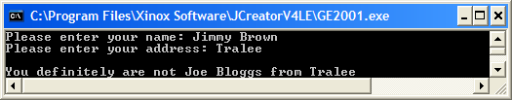

**(c)** Write the main() of a Java program that will test whether a whole number entered by the user is odd or even and display the appropriate message. The program would run as follows:

**Run 1 – The user enters an even number**

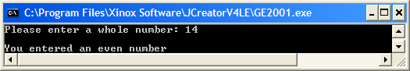

**Run 2 – The user enters an odd number**

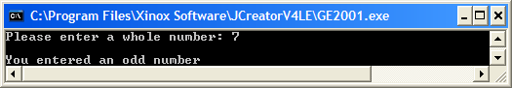

**(d)** Write the main() of a Java program that will ask the user to enter 2 salary values, which can contain a decimal point but cannot be negative. If the user enters any negative salary value then the program should display an error message saying “At least one of the salary values entered is negative …. quitting program now!”, otherwise the program should calculate and display the average of the 2 salary values to **2 decimal places**. Your program should run as follows:

**Run 1 – The first salary entered is invalid**

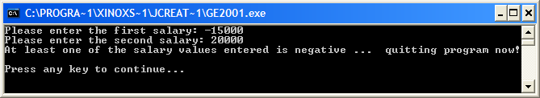

**Run 2 – The second salary entered is invalid**

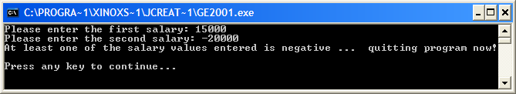

**Run 3 – Both salaries entered are valid**

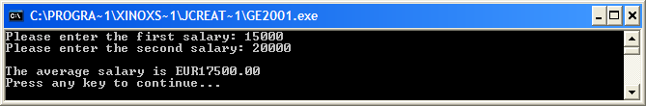

**(e)** Write a Java program that presents 3 options to the user when it runs. The options are:

1. Calculate the area of a triangle
2. Calculate the volume of a cylinder
3. Quit

Once the user has entered their choice (A, B or C) then the program should proceed to take the appropriate course of action. The decision making here should be carried out using a **switch** structure. If the user enters an invalid option then they should get an appropriate error message.

Note that the area of a triangle is given by the formula

$$A=\frac{1}{2}(base*penpendicular height)$$

while the volume of the cylinder is given by the formula

$$V= \frac{1}{3}πr^{2}h$$

where

$π$ is the number PI which you can **define as a constant** with the value3.142

r is the radius of the cylinder

h is the height of the cylinder

The program should display the area or volume to **3 decimal places**.

Your program should run as indicated in the following sample screenshots:

**Run 1 – The choice entered is invalid**

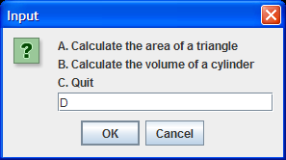 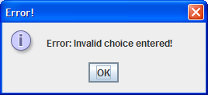

**Run 2 – The user chooses option A**

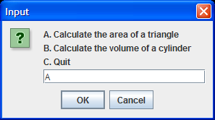 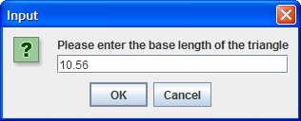

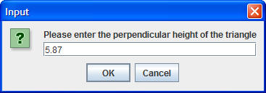 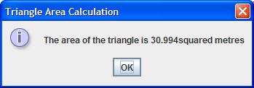

**Run 3 – The user chooses option B**

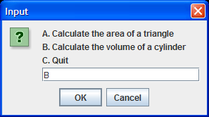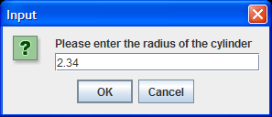

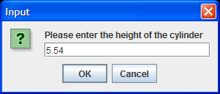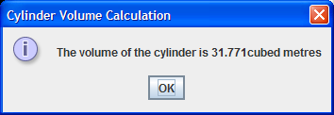

**Run 4 – The user chooses option C**

